
Data Flow System

Document Title: | Further of July 2007 VIRCAM Linearity Data
Document Number: | VIS-TRE-IOA-20000-0019
Issue: | 1.0
Date: | 2008-01-16

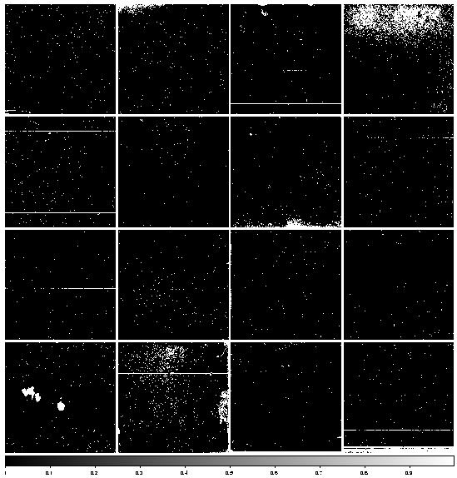
Authors: | Jim Lewis,  Peter Bunclark  (CASU) | Signature  And date:
Document  Approved by: | Mike Irwin  (CASU Manager) | Signature  And date:

Change Record

Issue | Date | Sections Affected | Description of Change/Change Request Reference/Remarks
1.0 | 2008-01-16 | All | New document

Contents

Change Record 2
List of Figures 4
1 Introduction 5
1.1 Goals 5
1.2 Applicable Documents 5
1.3 Reference Documents 5
1.4 Abbreviations and Acronyms 5
2 Overview of the data 6
2.1 Revision of Analysis Algorithm 6
2.2 Linearity Sequence Analysis 6
2.3 Monitor Sequence Analysis 17
3 Further Lessons Learned 19
4 Summary 19

List of Figures

Figure 2-1 Flux(ADU) versus Time(sec) for detectors 1-8 7
Figure 2-2 Flux(ADU) versus Time(sec) for detectors 9-16 8
Figure 2-3 Linearity curve detector 1 9
Figure 2-4 Linearity curve detector 2 9
Figure 2-5 Linearity curve detector 3 10
Figure 2-6 Linearity curve detector 4 10
Figure 2-7 Linearity curve detector 5 11
Figure 2-8 Linearity curve detector 6 11
Figure 2-9 Linearity curve detector 7 12
Figure 2-10 Linearity curve detector 8 12
Figure 2-11 Linearity curve detector 9 13
Figure 2-12 Linearity curve detector 10 13
Figure 2-13 Linearity curve detector 11 14
Figure 2-14 Linearity curve detector 12 14
Figure 2-15 Linearity curve detector 13 15
Figure 2-16 Linearity curve detector 14 15
Figure 2-17 Linearity curve detector 15 16
Figure 2-18 Linearity curve detector 16 16
Figure 2-19 Median flux (ADU) of monitor exposures versus time (fraction of day) for 2007-07-15 (Detectors 1-8). 18
Figure 2-20 Median flux (ADU) of monitor exposures versus time (fraction of day) for 2007-07-12 (Detectors 9-16) 18

1 Introduction

During July 2007, an engineering team from RAL, ATC & QMU obtained some 2,300 VIRCAM frames during EMC testing and other miscellaneous lab tests. A report from CASU [RD1] describes the subsequent analysis of the data in Cambridge. In that report the non-linearity of the data was only dealt with in a very cursory way. For this report we present a more detailed analysis of the linearity data.

Goals
The analysis has the following goals:
- Obtain a measure of non-linearity for each detector
- Use monitor sequences to correct for light source drift during the observations
- Determine a point in the linearity curves where the detectors begin to saturate
- Work out a good practice strategy for observing linearity sequences.

Applicable Documents

Reference Documents
- Analysis of July 2007 VIRCAM Engineering Data, VIS-TRE-IOA-20000-0018
- VISTA Data Reduction Library Design, VIS-TRE-IOA-20000-0010, v1.9, 2007-10-26

Abbreviations and Acronyms
CASU | Cambridge Astronomical Survey Unit
VDFS | VISTA Data Flow System
VIRCAM | VISTA Infrared Camera
VISTA | Visible and Infrared Survey Telescope for Astronomy

Overview of the data
Section 2 of [RD1] gives a complete description of all of the data that were taken during the July 2007 engineering data run. During that run, data were taken using the standard correlated double sampling read mode and an experimental reset-read mode. As a result of some of the analysis of that paper it has been decided not to offer the latter read mode for general observing with VIRCAM. Hence in this paper we’ll restrict our analysis to the linearity sequences done with correlated double sampling read mode.

Revision of Analysis Algorithm
In Section 2 of [RD2] a full mathematical treatment is presented for the analysis of data which have been taken on an instrument without a shutter and which are reset corrected. This analysis depends critically on the timing model of the reset and read stage of the exposure and is pretty much a general treatment. The VIRCAM detectors are run in a mode where the reset time is equal to the read time, which is a far simpler timing model than for many detectors. This allows for a simplification of the analysis and leads to a more robust solution. A full explanation of how the method has been modified will be included in the next release of [RD2].

A further modification to the algorithm includes monitoring the constancy of the ambient light source during the observations of the linearity sequence. This is done by taking a series of exposures with a single exposure time, each element of this series being interspersed with the exposures done for the linearity sequence. If the mean flux of the light source is varying during the linearity sequence it can be seen by changes in the median flux in the monitor sequence. Any deduced change in the light source can be included as a correction factor for the exposures in the linearity sequence. These monitor sequences were actually taken during the July 2007 run, but were not analysed in [RD1]. All of the results that follow in this paper were done with statistics that have been corrected for any perceived background change as seen in the monitor sequences.

Linearity Sequence Analysis

The first thing to note about the linearity results is that although each data channel is being analyse separately, the linearity results are very similar for all channels in an individual detector. The raw flux versus time curves for all sixteen detectors can be found in Figure 2-1 and Figure 2-2. Although there are eight curves on each graph, the curve for each detector is clearly marked. Table 2-1 below gives the calculated value of the average non-linearity for each detector and is defined at a nominal input flux of 10000 counts. This was done initially by defining a saturation level of 40000 counts for each detector and doing a 4th order fit. The table shows that none of the detectors came very close to the nominal saturation level and hence it was impossible to define a true saturation level for most of the detectors. The exceptions are detectors 1 and 5 (starred values in the data range column). These showed quite strong saturation tendencies at roughly 33000 and 24000 counts respectively.

During the course of this analysis it became quite clear that the nominal linearity estimated from this analysis could be variable on the 1-2% level depending upon the order of the polynomial that was fit. This was in spite of the fact that the formal error in the fit is quite small. We feel that this is due mainly to the fact that the number of points at the lower flux levels (where one would expect nearly linear behaviour) is quite small and hence the linear term of the fit is very poorly constrained. Thus the estimate of non-linearity present in Table 2-1 should only be considered a first guess.

In order to try and give a rough idea of the run of non-linearity with flux level we did a linear fit of the first few points of each flux versus time curve and then subtracted this linear estimate from each point on the curves. The resulting graphs of residual versus input flux are shown in Figure 2-3 to Figure 2-18. The curves for detectors 1 and 5 clearly show the effect of saturation at the bright end.

The final item that pops out of the linearity analysis is the percentage of bad pixels on each detector. This is presented in the final column of Table 2-1.

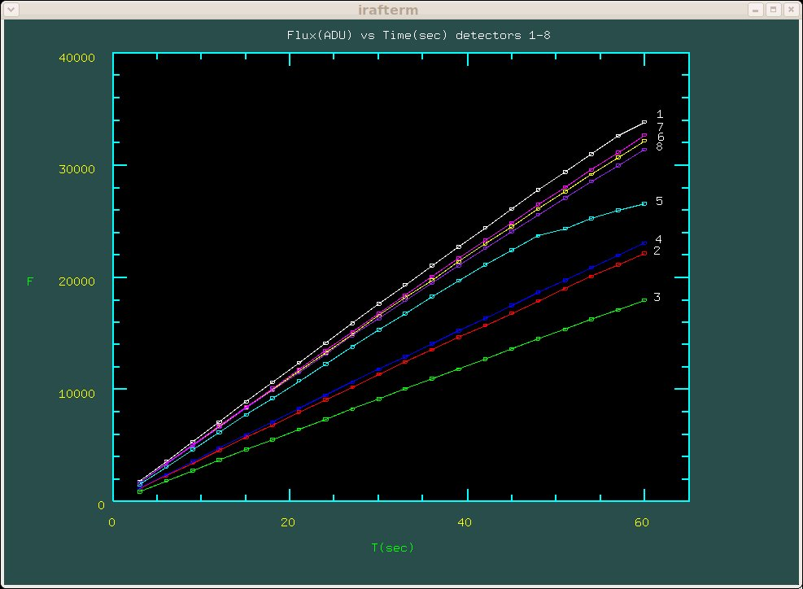
Figure 2-1 Flux(ADU) versus Time(sec) for detectors 1-8

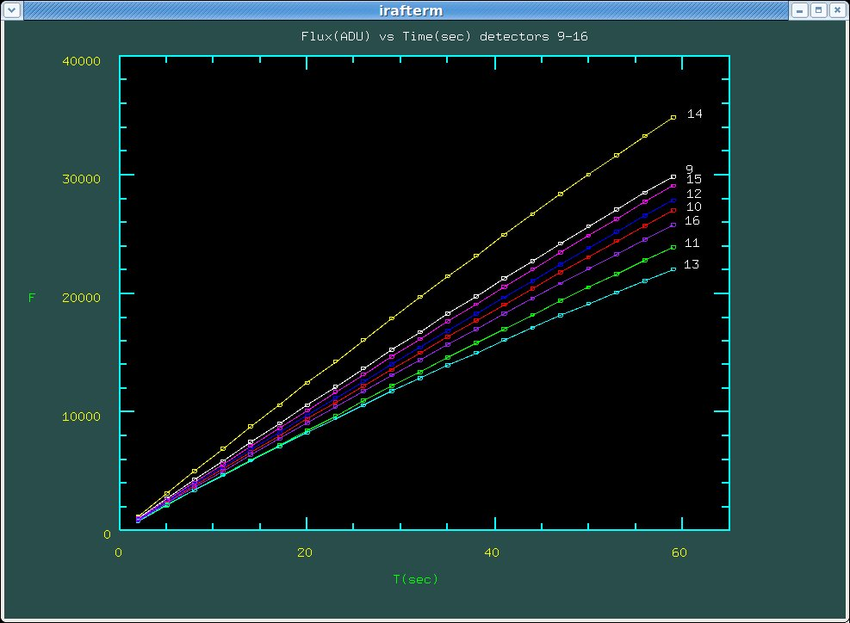
Figure 2-2 Flux(ADU) versus Time(sec) for detectors 9-16

detector | non-linearity  (%) | non-linearity error  (%) | data range  (10**3 ADU) | Bad Pixels  (%)
1 | 0.89 | 0.06 | 2-33* | 2.7
2 | 0.96 | 0.05 | 1-22 | 0.1
3 | 2.10 | 0.05 | 1-18 | 0.2
4 | 1.92 | 0.05 | 1-23 | 0.2
5 | 4.48 | 0.40 | 2-24* | 0.1
6 | 1.67 | 0.04 | 2-32 | 0.3
7 | 0.96 | 0.03 | 2-33 | 0.3
8 | 2.36 | 0.04 | 2-32 | 0.4
9 | 1.43 | 0.08 | 1-30 | 0.7
10 | 0.69 | 0.07 | 1-27 | 0.3
11 | 1.49 | 0.04 | 1-24 | 0.3
12 | 0.37 | 0.09 | 1-28 | 0.3
13 | 6.09 | 0.05 | 1-22 | 1.1
14 | 0.69 | 0.07 | 1-35 | 1.4
15 | 0.11 | 0.06 | 1-29 | 0.9
16 | 0.52 | 0.11 | 1-26 | 1.5
Table 2-1 Linearity Results

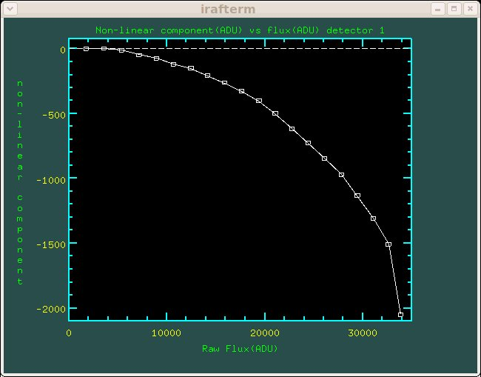
Figure 2-3 Linearity curve detector 1

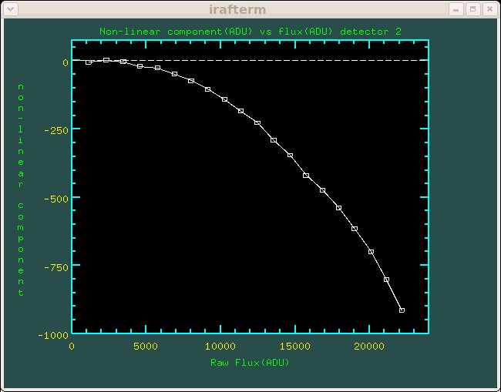

Figure 2-4 Linearity curve detector 2
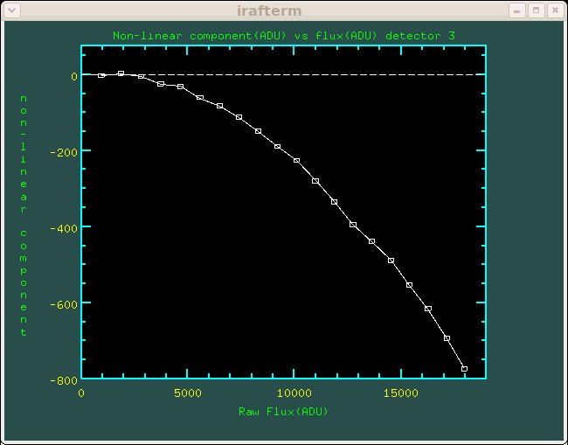
Figure 2-5 Linearity curve detector 3

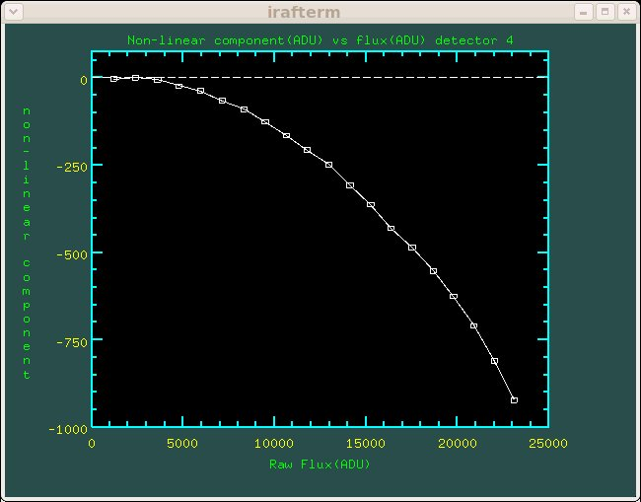

Figure 2-6 Linearity curve detector 4
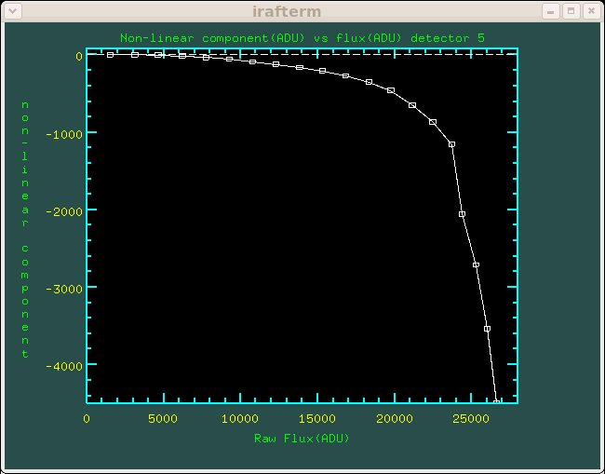
Figure 2-7 Linearity curve detector 5

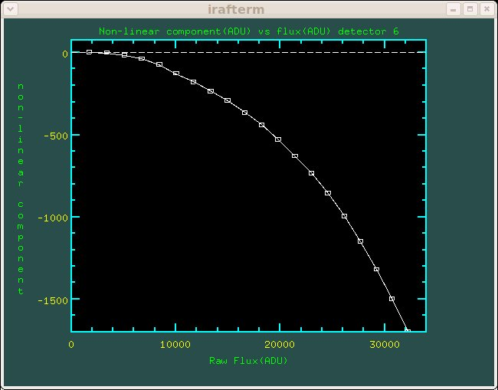

Figure 2-8 Linearity curve detector 6
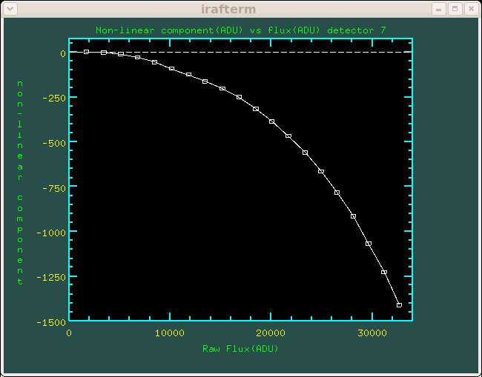
Figure 2-9 Linearity curve detector 7

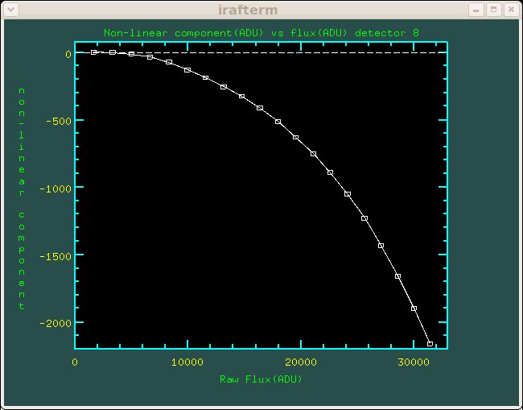
Figure 2-10 Linearity curve detector 8

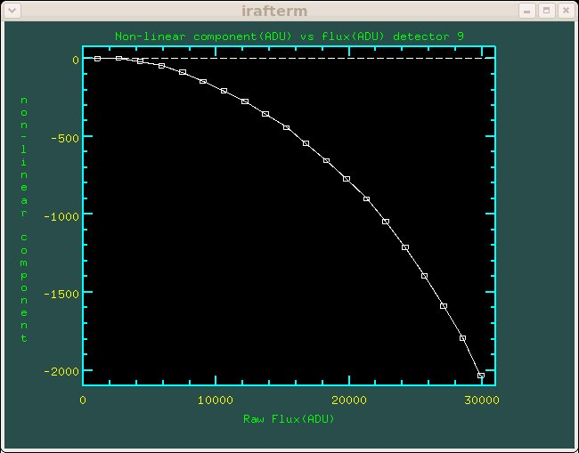
Figure 2-11 Linearity curve detector 9
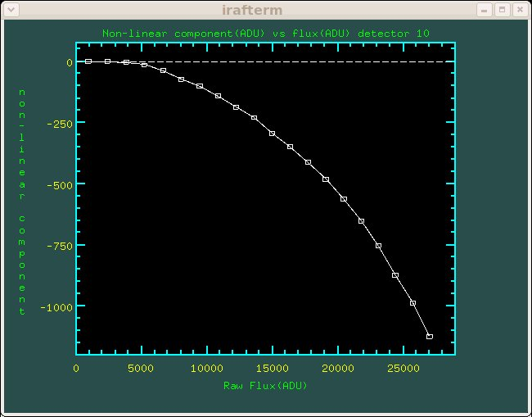

Figure 2-12 Linearity curve detector 10
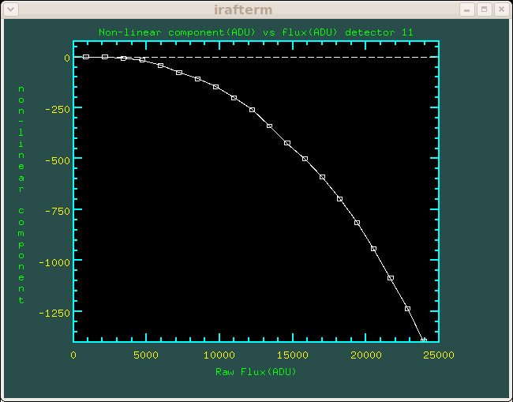
Figure 2-13 Linearity curve detector 11
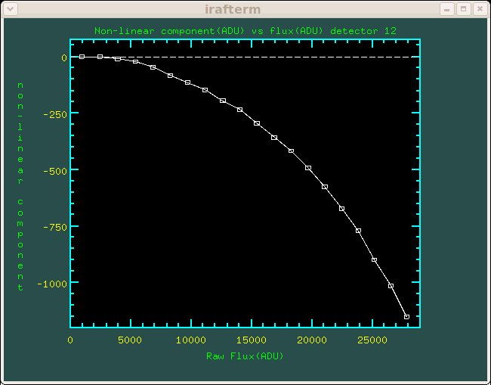
Figure 2-14 Linearity curve detector 12
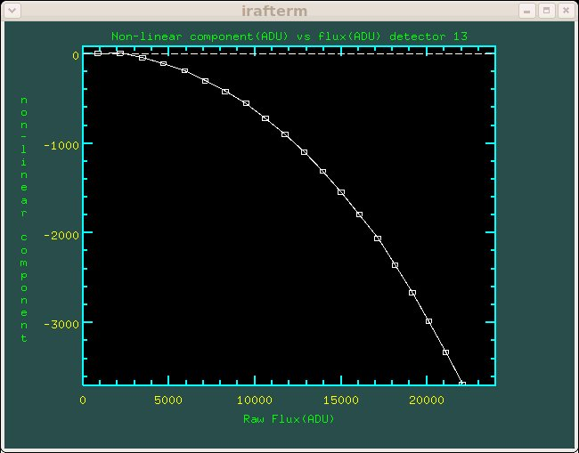
Figure 2-15 Linearity curve detector 13
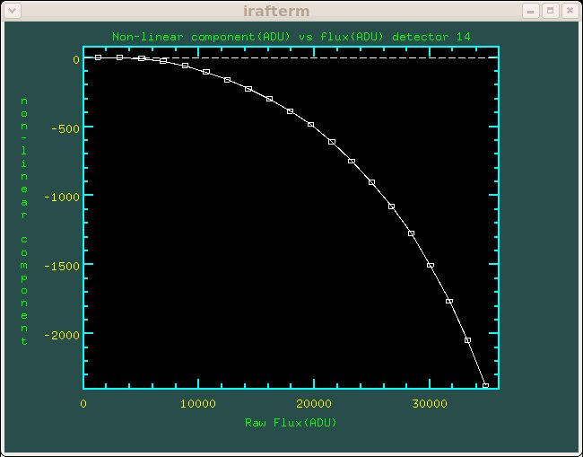

Figure 2-16 Linearity curve detector 14
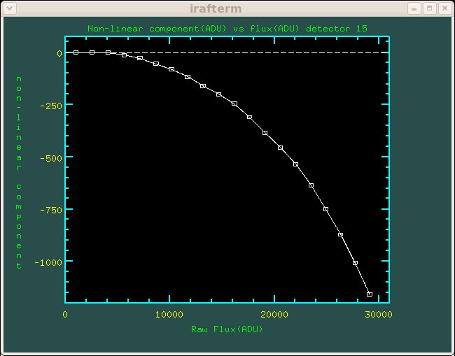

Figure 2-17 Linearity curve detector 15
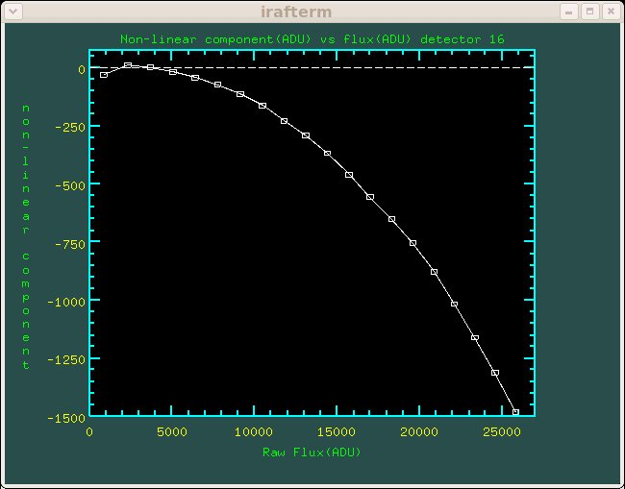

Figure 2-18 Linearity curve detector 16

Monitor Sequence Analysis

As mentioned before, the flux of the ambient light source was monitored by taking an extra 15s exposure between each member of the linearity sequence. The background levels for a linearity sequence exposure were then scaled to mimic any change derived from the values in the monitor sequence exposures done just before and just after.

Figure 2-19 and Figure 2-20 show the run of the calculated adjustment factors as a function of time for detectors 1 to 8 and 9 to 16 respectively. The factors are calculated by taking the run of median flux for a given detector and normalising each one by the median of the run. Each detector is represented in these figures by a different colour.

Both sets of plots show a steady increase in the background flux as a function of time. The naïve (yet possibly true) interpretation of these curves is that the background light source really was varying and getting brighter as the linearity sequence was being observed. However, such an increase could also indicate a persistence issue with the detectors. The linearity sequence was observed with the longest exposures done last and it is entirely possible that the increase that we see in the monitor sequence represents a build-up of persistent flux as a result of increasing integration times. If this is the case then it will have serious consequences for observing both dome and twilight flats, both of which are vital for proper calibration of the science data.

Further tests need to be done off sky to determine whether persistence of this kind is a real issue for linearity determination, not to mention as a serious effect for the science data. For one thing we could reverse the order of exposure in the linearity sequence by doing the long exposures first. If persistence is the real problem the curve we get for the monitor series should decline with time.

Although the plots on these figures also bear very similar shapes, there does appear to be a difference between them in scale. The most obvious one of these is the light blue squares in Figure 2-20 which corresponds to detector 13 and which has quite a high non-linearity coefficient. The nominal gain of each detector is also different so that the median values of the monitor series will all fall on different parts of the linearity curves for each detector. This is the reason for the spread in the curves, especially seen in Figure 2-19. Once we have better linearity sequences and are able to tie down the first order coefficient better, we can repeat this experiment by linearising the monitor exposures. This should cause all the points in these two figures to coincide much better.
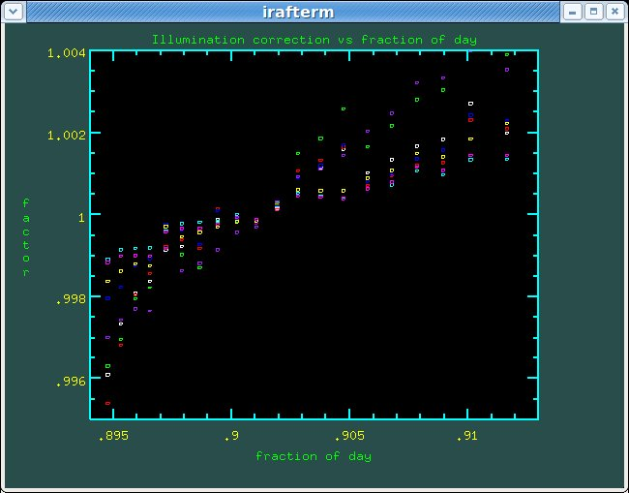
Figure 2-19 Median flux (ADU) of monitor exposures versus time (fraction of day) for 2007-07-15 (Detectors 1-8).

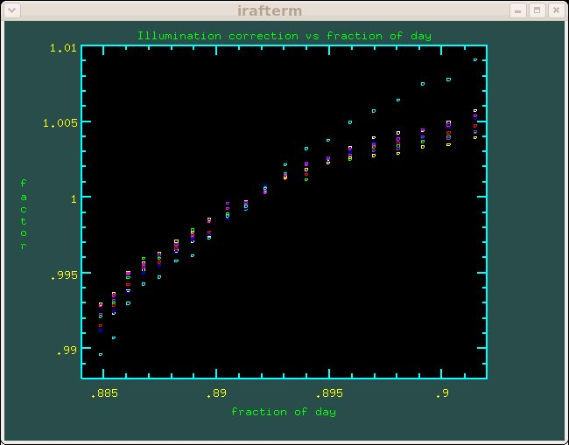
Figure 2-20 Median flux (ADU) of monitor exposures versus time (fraction of day) for 2007-07-12 (Detectors 9-16)

Further Lessons Learned

The results presented here are based entirely on linearity sequences taken with a narrow band filter. The data taken in July 2007 also included several linearity sequences done with broadband filters. These tended to saturate with at quite low exposure times (~3 seconds) and hence to try and get as many points on the calibration curve as possible, the observers did exposures every 0.1 second. The trouble with this strategy is that the minimum exposure time (and hence the reset frame exposure time) is roughly 1 second, meaning a correlated double sampled exposure of 1 second which has been reset corrected is already about 25% up the ramp to saturation. This leaves a big hole in the calibration curve for fluxes below this level and fitting a curve of order higher than about 3 can cause all sorts peaks and troughs to appear in this region. Since the linearisation scheme is essentially an inversion of this polynomial expansion, the inverted function can become multi-valued and the solution is then a non-sense. The observers realised that this was a potential problem and redid the observations with a narrow band filter to try and make sure that the linearity curve is well sampled in all regions. Unfortunately as we have seen there was still a paucity of data in the lower flux regions and further observations will be needed before we can characterise the linearity of the detectors properly. In the long run observing procedures will have to be established which cover the filters to be used, the brightness of the light source and the exposure times to be used.

Summary

We can summarise the results of this paper as follows:
- Although we can fit the linearity curves using a polynomial function, the first order terms of the fits are not well constrained by the current data set. More finely spaced observations are needed especially in the low flux regions.
- We are currently unable to give a good estimate of the saturation levels for most of the detectors. Any future sequences that are observed must extend further into the high flux regions and well into saturation for all detectors before this can be modelled properly.
- The sequences used to monitor the light source stability show an increase in flux with time. Additional observations need to be done to demonstrate whether this is a real variation in the ambient light source, or a long time constant persistence effect.
- The linearity analysis is clearly very sensitive to how well the data are observed. Once we have assembled and analysed a good body of linearity data, strict procedures must be developed covering the exposure times, filters, light sources, etc in order to ensure that linearity sequences taken during science operations are fit for purpose.

__o☺o__

